Make your own seaweed fertiliser
(An activity for when you’re near the sea!)
We are researching how to make useful things from green seaweed blooms
When nutrients from farms and factories enters the sea, seaweed can grow really fast! This is called a seaweed bloom. The green seaweed Ulva is responsible for almost half of seaweed blooms around the world. They build up on beaches and rot, causing a lot of environmental and economic problems.  However, if these seaweed are collected before they reach the shore they can be used to make useful things and to make money. Ulva contains a special sugar, and at Aberystwyth University we are working out what we can use them for and how to do it. |  |  | 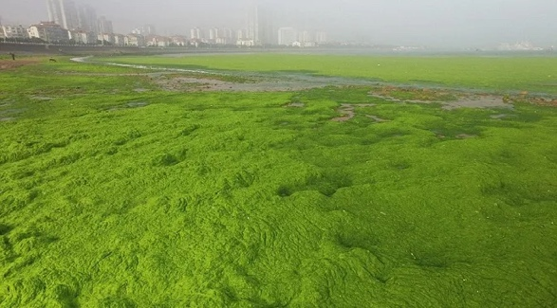
 |  |  | It took more than 10,000 people and around 1000 fishing boats to clean up the green tide that occurred in Quingdao, China just before the 2008 Olympics.
Activity 1
Seaweeds contain a lot of valuable ingredients that are used in different household products which you use all the time, like toothpaste, shampoo, shower gel, make up, sunscreen, plant fertilizers etc. They are also used in foods such as ice creams, yogurt, jellies, chocolates, butter etc. Seaweeds are also eaten as a vegetable in some Asian cuisines. For example, the dark green-black flat sheets used to roll sushi are actually dried seaweed. Seaweed based products are sustainable and eco-friendly.
  - Go around your house, check the ingredients section on the pack of all products and make a list of those that contain seaweed extracts. They will be listed down as seaweed extract or look out for words such as carrageenan, alginate, or agar.
  - Draw a picture of how you imagine seaweed grows in the sea (Hint: You will most likely find them attached to rocks). When you visit the shore for the next activity, check if your picture matches what it looks like.
Seaweeds can be grouped into three distinct types based on colour. When you visit the shore or beach, can you identify the three different colours of seaweed?
 |  | THIS ACTIVITY IS PART OF FUTURES: A FESTIVAL OF DISCOVERY WHERE YOU CAN EXPLORE THE PAST, CREATE THE PRESENT AND IMAGINE THE FUTURE… Find out more at www.futuresnight.co.uk

Activity 2
DIY Liquid Seaweed Fertilizer

Seaweeds can be used to make an excellent organic fertilizer for your home garden. They contain all the valuable nutrients that can help your plants grow without the use of synthetic or chemical based fertilizers. Although some fertilizers available in the shops are made of seaweed, they can be expensive! Making your own seaweed fertilizer costs nothing and you can be sure that there are no chemicals in them. You can follow this simple recipe to make some liquid seaweed fertilizers at home.

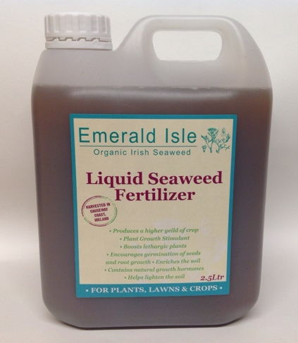
- Collect around 3/4th of a bucket of seaweed (Any colour) from the beach. Make sure you collect only what is washed on the shore and not those that are attached to rocks or actively growing.
DIY
- Rinse the seaweed with fresh water or rainwater if available.
- Add fresh water or rainwater to the bucket, just enough to cover all the seaweed in it.
- Cover the bucket with a lid and store it in a corner outside your house. Keep it as far away from doors and windows as possible as it will smell bad in a few weeks.
- Stir the seaweed with a stick every 3-4 days. The mixture will start to smell after a while. Do not worry, the smell will eventually disappear. Disappearing of the smell is an indicator that your fertilizer is ready to use.
- Once ready, pour the liquid out from the bucket into another container. The seaweed waste can be added to your compost bin. Do not add the waste directly to the soil as it will be too strong for the plants.
- Mix some of the seaweed feed with 9 times the amount of water, to dilute it.

- Use the diluted liquid to water the plants in your garden.

In addition to liquid seaweed fertilizer, there are other ways in which seaweed can be used to help your plants grow. This video describes the benefits of seaweeds as fertilizers and explains the different ways that they can be used.
Green tides that occur every year at Brittany in France are visible from space. Click here to read the research paper!
Dr Valerie Rodrigues, IBERS, Aberystwyth University

